2026 St. John Vianney CYO Cross Country Registrations
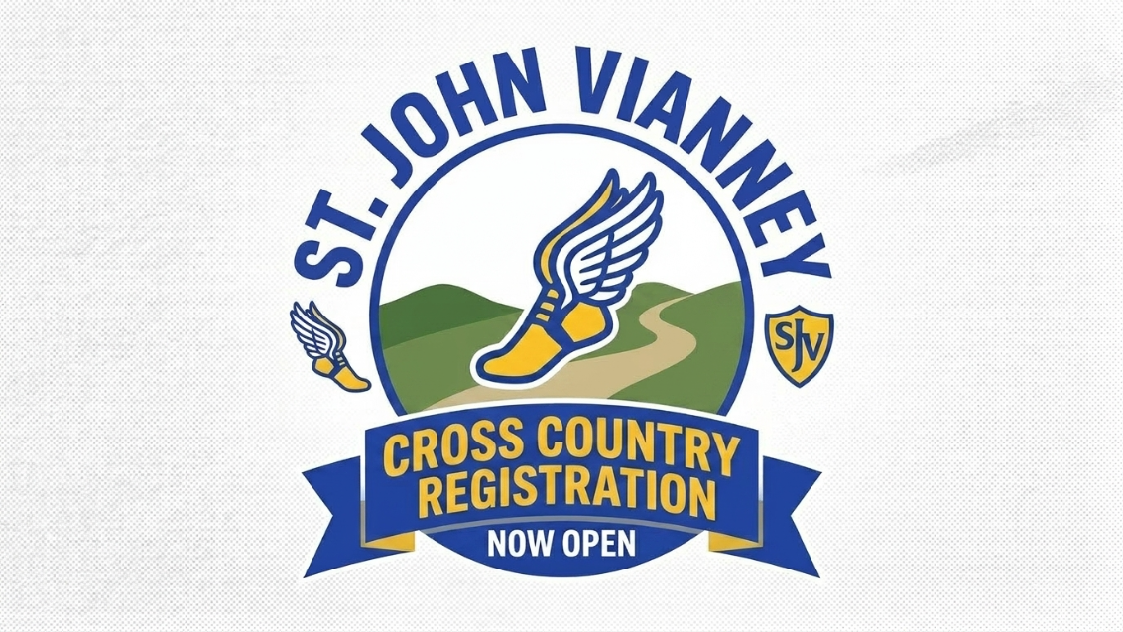

The Fall CYO Cross Country season is now open to boys and girls students in grades 1 through 8 that attend school at All Saints, enrolled in PSR or is a parishioner at SJV.
Cross Country is a great sport for children looking to get in shape, build endurance, increase their agility and most importantly have fun!

Registration will close on Sunday, June 14th and will cost $105. To register, please click here or go to https://reg.sportspilot.com/106169. You can also go to the St. John Vianney website sjvmentor.org and click on the registration link on the home page.

Only this CYO Physical form will be accepted in Privit. Click here or go to https://stjohnvianney.e-ppe.com/index.jspa. All forms and questions must be answered in order to participate.

If you have any further questions, please contact Bob Jacobs rjacobs79@gmail.com.
Athletic Director - St. John Vianney

